**"Guided Capstone Project Report"**

* **Objective:**

To offset the operation cost of the extra lift chair through increasing the adult weekend ticket price.

* **Data available for modeling:**
  + **We have following data for 330 different resorts:**

“Name, Region, state, summit_elev, vertical_drop, base_elev, trams, fast Eight, fast Sixes, fast Quads, quad, triple, double, surface, total_chairs, Runs, Terrain Parks, Longest Run_mi, Skiable Terrain_ac, Snow Making_ac, days Open Last Year, years Open, average Snowfall, Adult Weekday, Adult Weekend, projected Days Open, Night Skiing_ac”

* + **From the following states: Resorts from 35 states were included on our data set**

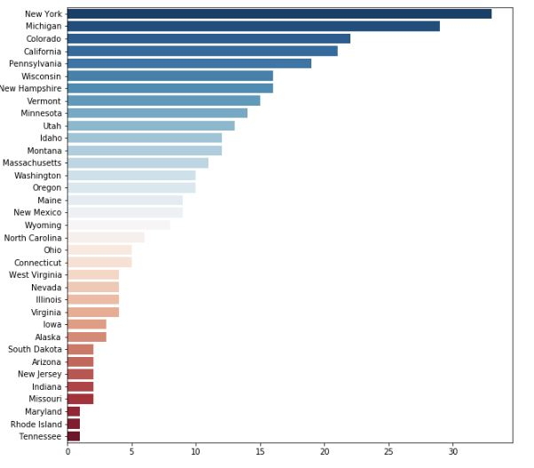

**Figure 1-Distribution of the States**

Note: Since region and states columns included identical information, we dropped the “Region” from our data frame.

* + **Before the modeling, data cleaning and data wrangling were performed to clean the dataset and make it ready for the modeling.**
* **Accepted Model:**

**X=df.drop(['Name','AdultWeekend','state','Region','summit_elev','base_elev'], axis=1)**

**y=df.AdultWeekend**

**scaler = preprocessing.StandardScaler().fit(X)**

**X_scaled=scaler.transform(X)**

**y=y.ravel()**

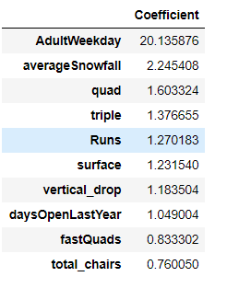**X_train, X_test, y_train, y_test = train_test_split(X_scaled, y, test_size=0.25, random_state=1)**

**lm = linear_model.LinearRegression()**

**model = lm.fit(X_train,y_train)**

**y_pred = model.predict(X_test)**

**print(explained_variance_score(y_test, y_pred))**

**mean_absolute_error(y_test, y_pred)**

**EVS=0.926**

**MAE=5.465**

* **Price prediction for the Big Mountain Resort according to the Model:**

BM_pred = model. predict (BM_scaled)

print ("The expected June Mountain Resort adult weekend price is $%s " % ' '. join (map (str, BM_pred)))

The expected Big Mountain Resort adult weekend price is $59.70

